**8 Memo**

To: Professor Pisano

From: Ben Brewer, Ibrahim Chand, Alex Prior, Allen Zou

Team: NoiseHub Team 8

Date: 11/21/2021

Subject: First Prototype Test Report

1. **Equipment and Setup**

**Hardware:**

* Raspberry Pi 4B
* Thermistor
* 12W USB C Power Adapter (RPI)
* 4.7kΩ Resistor (Thermistor)
* Laptop (AWS observation, Pi SSH)
* Mobile Device (App observation)
* Garmin Lidar-Lite v4

**Software:**

* Python Scripts:
  + Read thermistor and LIDAR data
  + Send thermistor and LIDAR data to AWS IoT core
* AWS Cognito User Authentication
* AWS DynamoDB User Preferences Data
* AWS Timestream Data

**Setup:**

The Raspberry Pi will be turned on and connected to one team member’s mobile hotspot through a monitor and keyboard. Next, the team will ensure the LIDAR and thermistor are properly wired. Then, AWS Timestream and IoT Core will be pulled up on one member's laptop, and the mobile app running on Expo Go will be pulled up on another member's mobile device.

**2.0 Measurements Taken**

The team measured a change in temperature and distance from the thermistor and LIDAR sensors respectively. Out of the ten sampled data points, we saw an increase in temperature after a team member held the thermistor in their hand, and a change in distance as a team member moved their hand towards and away from the LIDAR sensor. As shown from the SQL query to AWS Timestream, these values accurately changed over time:

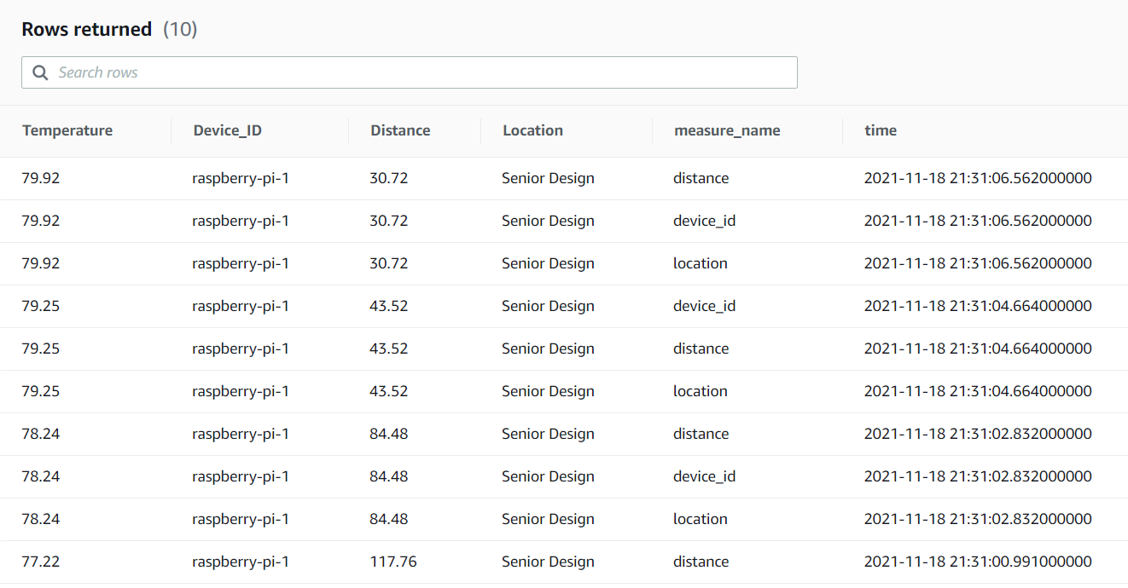

**3.0 Conclusions**

From the measurements, we can confirm that the Raspberry Pi is successfully measuring thermistor and LIDAR sensor data, packaging the data into a payload, and sending it to AWS IoT core via MQTT and then forwarded to AWS Timestream. The sensors are also correctly responding to changes. For example,when we wrapped our hands around the thermistor, the temperature readings rose and when we moved our hand back and forth in front of the lidar, the distance readings moved accordingly.